**7.1.8 Describe the Institutional efforts/initiatives in providing an inclusive environment i.e., toleranceand harmony towards cultural, regional, linguistic, communal socioeconomic and other diversities (within 500 words).**

The Institution stands testimony to Unity in Diversity as the students join the Institution through DOST admissions, in which students of all religions and social classes take admissions. The College is highly sought after, which itself stands as testimony to the prevalent sense of camaraderie and harmony. To further enhance this spirit, Traditional Day and various festivals are being conducted to highlight the specialty of culture, region, language, and community. The Institute promotes Inclusiveness of all cultures and traditions within the College.

* Inculcation of strong moral and ethical values
* There is a tradition of celebrating many festivals and traditional days on the campus.
* The students and staff are encouraged to practice universal, ethical, and social responsibility.
* Awareness is being created among the students regarding the different National Festivals, Important National Leaders, and Commemorative days to help to mold them into responsible citizens.

**Bathukamma :**

Bathukamma is a state festival of Telangana. The culmination day is the Ashtami. The flowers are arranged in the morning, followed by puja and the offering of naivadyam. In the evening, women gather near water beds, sing, dance and distribute naivadyam, turmeric, and Kumkum. Then they immerse the flowers in the water. The entire festival is a feast to the eye. The flowers used have been found to have antimicrobial properties.

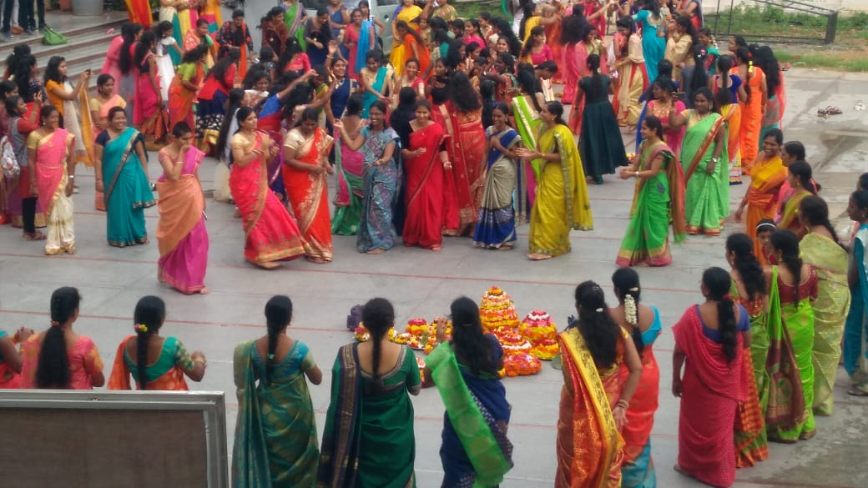 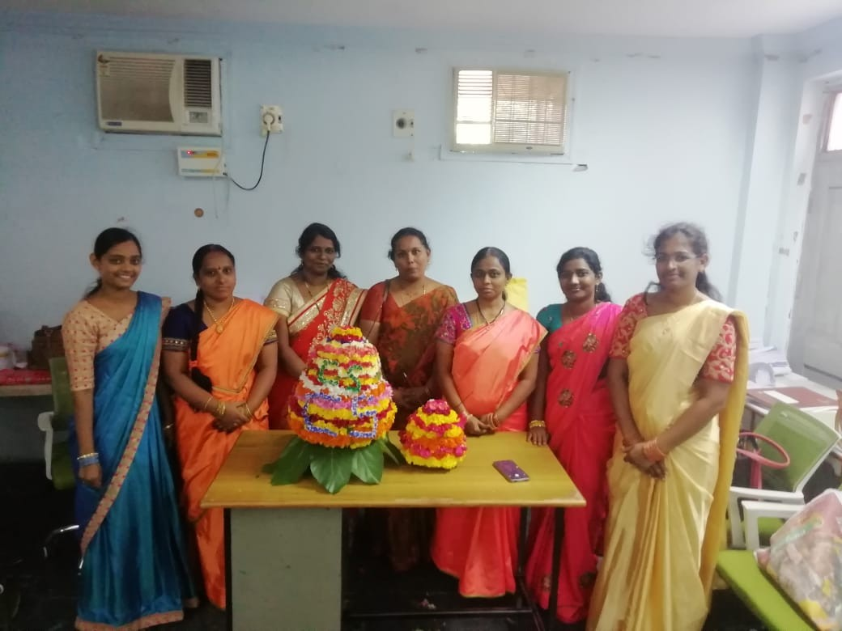

**Krishna Janmashtami:**

Krishnashtamimarks the birth of Sri Krishna in the prison where his mother and father are held captive. It is celebrated with fasting and breaking of vutti(pot) which is tied high. Different types of prasadams are prepared on that day.

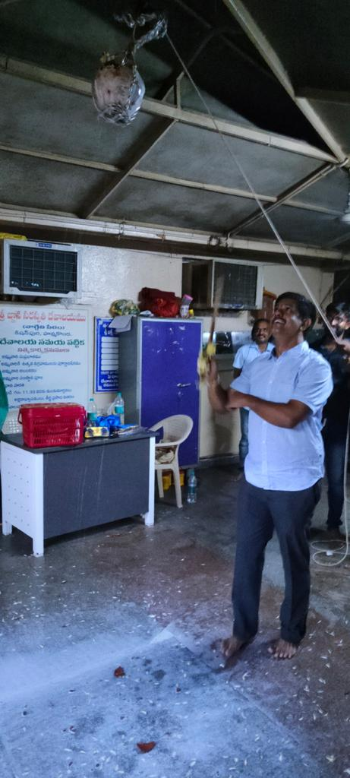

**Traditional Kuchipudi Dance:**

Kuchipudi dance is originated from Kuchipudi in Krishna district of Andhra Pradesh. It is known for its graceful and intricate hand and feet movement.

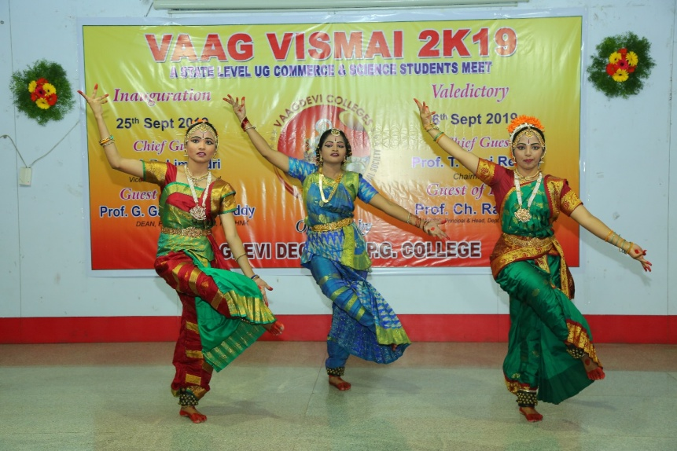

**Vinayaka chavithi Navaratri** is celebrated across the departments, with all the departments taking turns in performing puja and prasadam. On the last day, the idol is moved after offering puja. Prasadam is distributed, and a grand nimajanam procession starts from the College amidst drum beats, deepam, kolatam performing girls

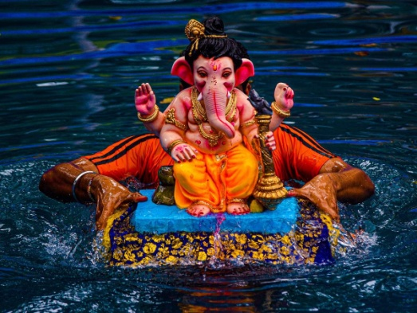

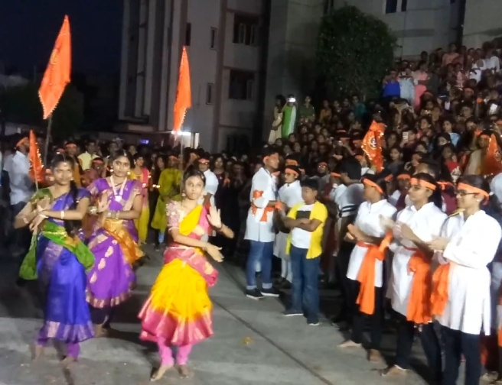 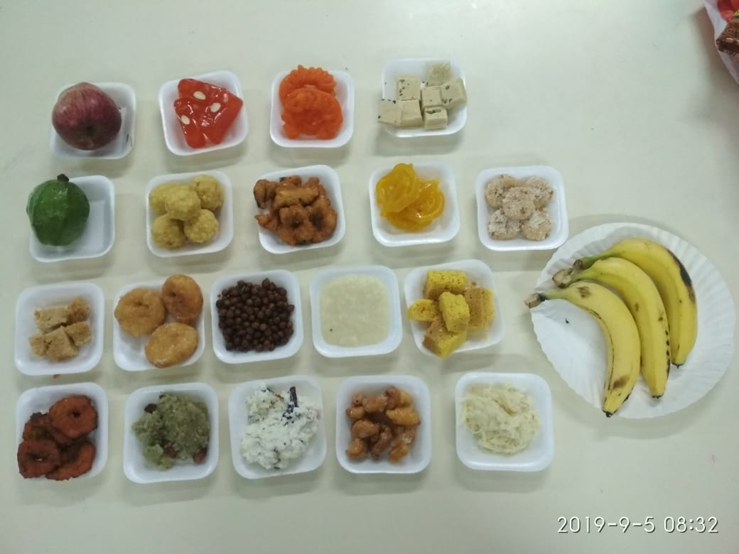

Procession for nimajanamPrasadam

**Traditional Day:**

**For the celebration of Traditional** day in Theme, the state is selected. The culture of different states is depicted in dress, pictorials, videos, dance forms, songs, dialects, etc. Stalls are erected to highlight their food, cultural background, the festivals they celebrate, and their traditional dances. Faculty are sportive and come in the conventional outlook of those states. The students have a gala time celebrating these events and enjoy themselves at the stalls having food, games, Mehendi, nail art, and a Jukebox, creating a festive environment

**Rajasthan Traditional Dress**

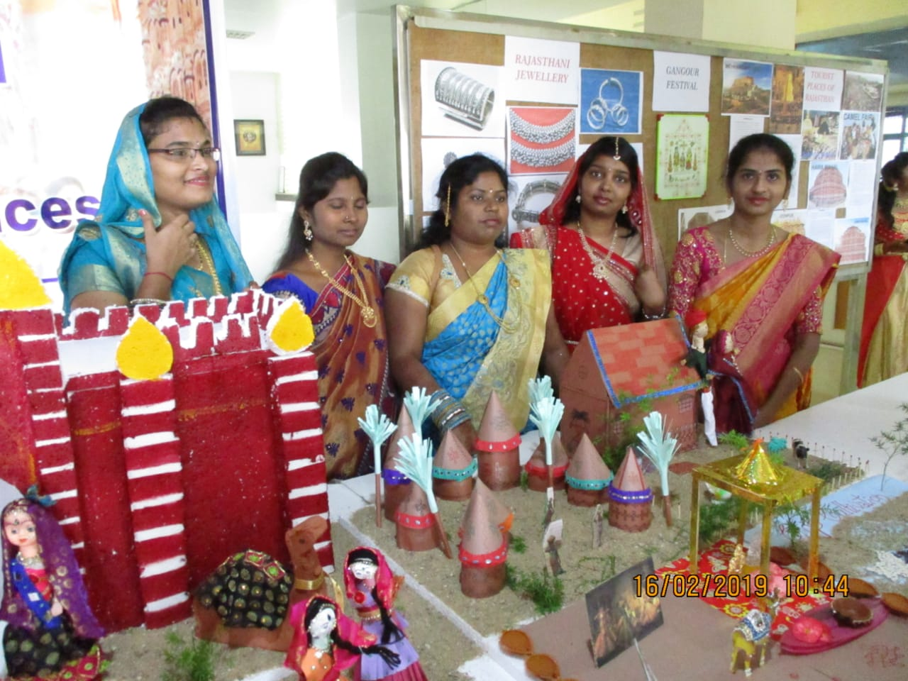

Rajasthan culture was depicted along with their culture and traditions. The dresses are colorful. Men wear colorful turbans. The picture depicts Thar desert and an oasis.

**Gujarat Traditional Culture:**

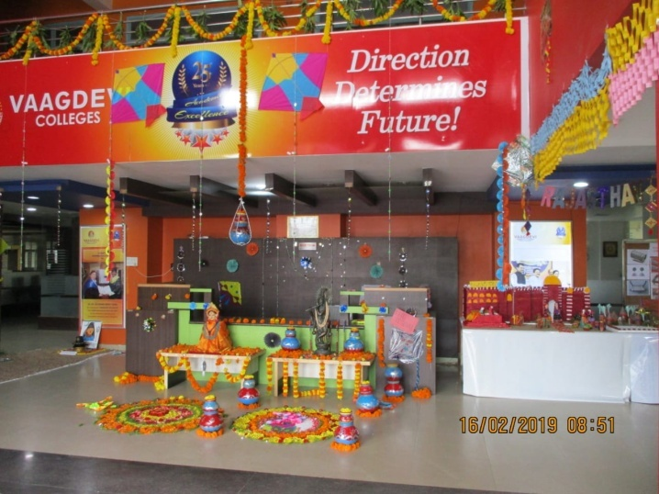

Gujarat is known for its dressing style, temples of Dwaraka, Somnath, Arabian sea, its dhokla, khakra, celebration of devi Navaratri and dandiya.

**Maharashtra Traditional Dress**

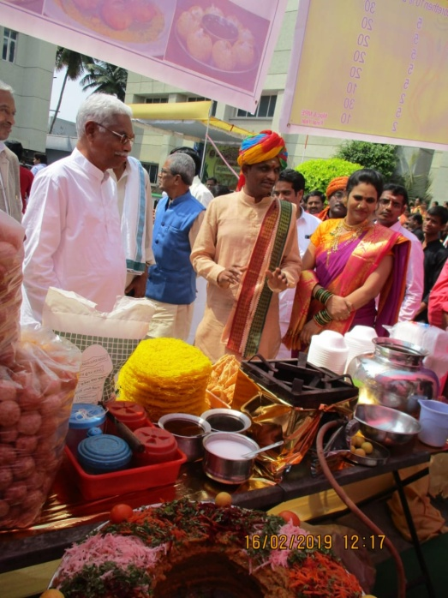

Traditional Maharashtra attire. Maharashtra is known for Mumbai, Commercial capital of India. Ganapati celebrations, Pav bhaji etc.

**Kerala Traditional Dress:**

**Kerala** men wear lungi and women wear mundu set. In temples they do not allow people without traditional attire. Kerala is also known as God’s own land for its pristine beauty and its Onam celebrations, snake boats. It is famous for puttu, Appam.

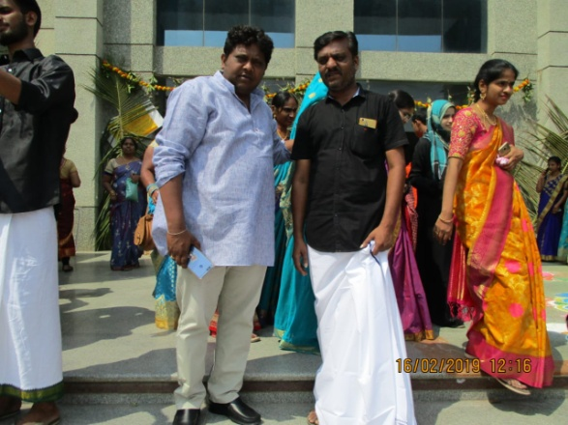

**Andhra Pradesh – Sankranthi** is a festival of harvest and it signifies the harvest of paddy and the customs all revolve around the occasion where the fruit of hard work comes home in form of harvest. Every house is decorated with flowers, rangavalli and gobbammalu. Pongal a sweet porridge from freshly harvested rice is prepared and definitely eaten on that day. Pala Thalekalu, rice flour sev is added to milk to prepare porridge along with jaggery. The pulihora is prepared with tamarind pulp. In villages cock fights, bull races etc are organized.

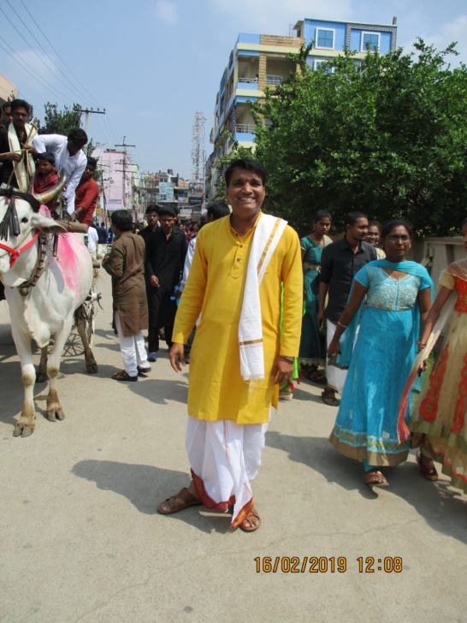

**Women in Traditional Devotion**

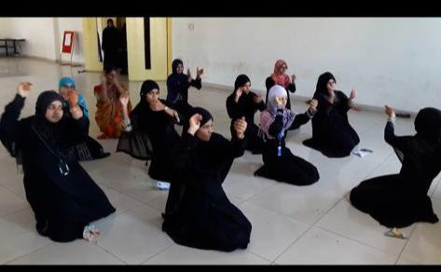

**Traditional Rangavalli**:

Rangavalli is a tradition being followed in southern states. Generallycowdung is mixed in water and then sprinkled. On this part the designs are drawn. Here designs are put either by joining dots or freehand or by using certain accessories. In south India rice flour is used along with fine sand to make it free flowing. Usually ants do not enter the homes as the rice flour itself becomes food.

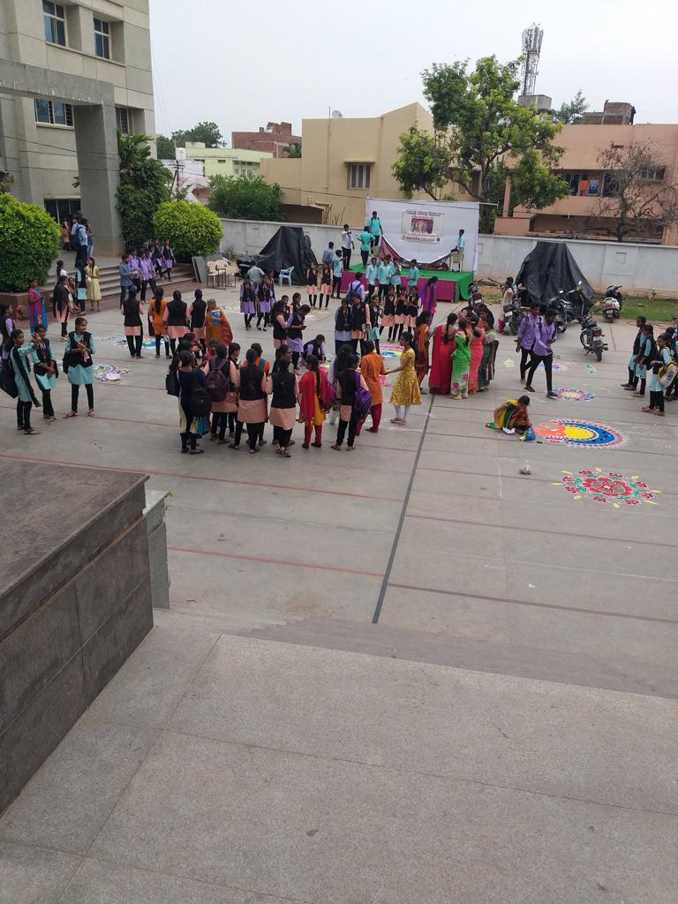

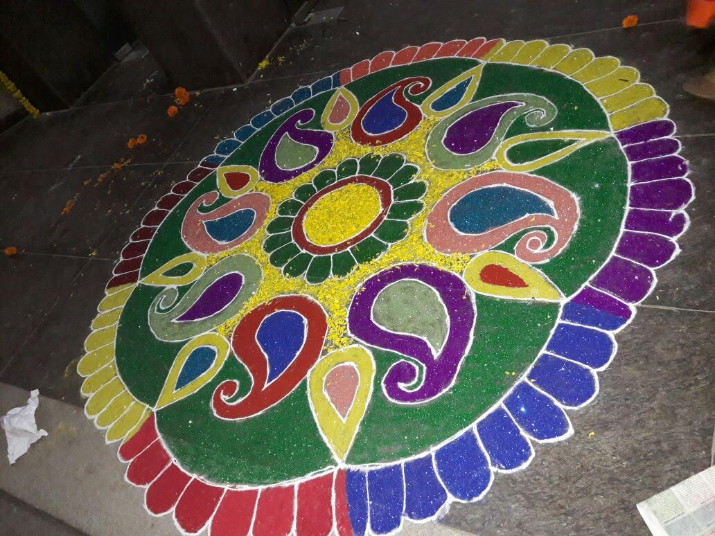

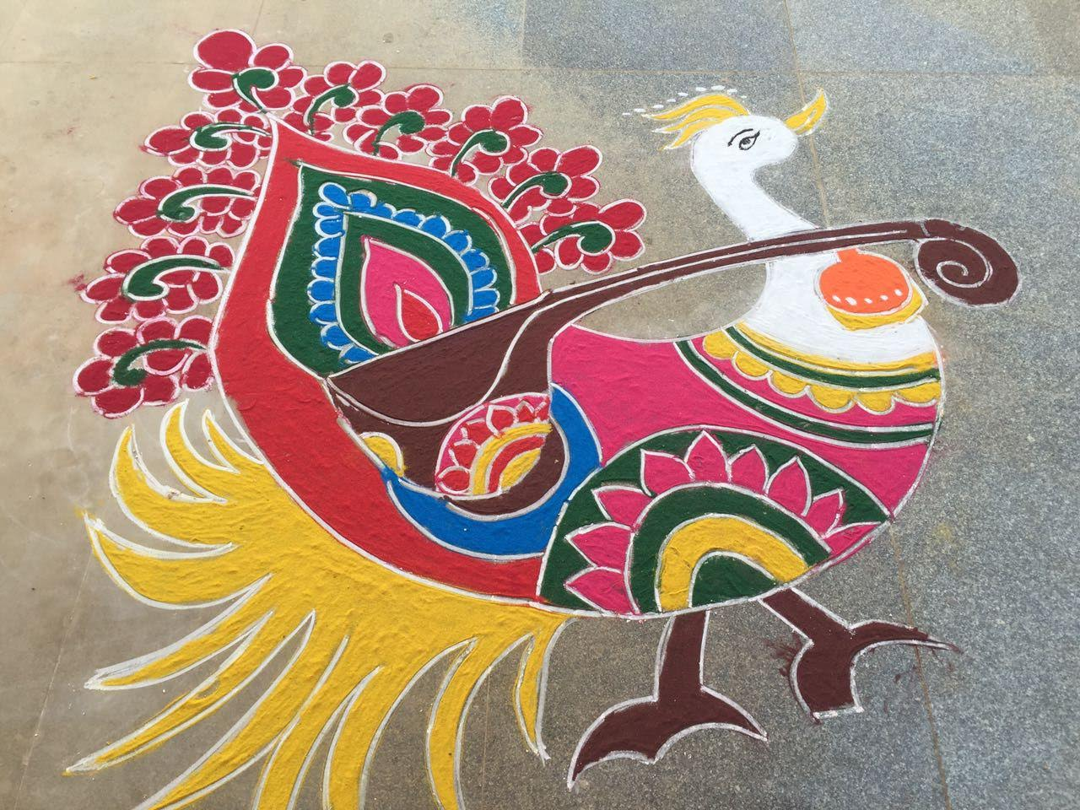

**Rakhi**

Raksha Bandhan promotes the bond between brother and sister. Rakhi is a festival which celebrates the relationship between brother and sister. Sister ties rakhi and offers tilak and sweets. Brother gives gifts and promises to protect his sister for lifetime.

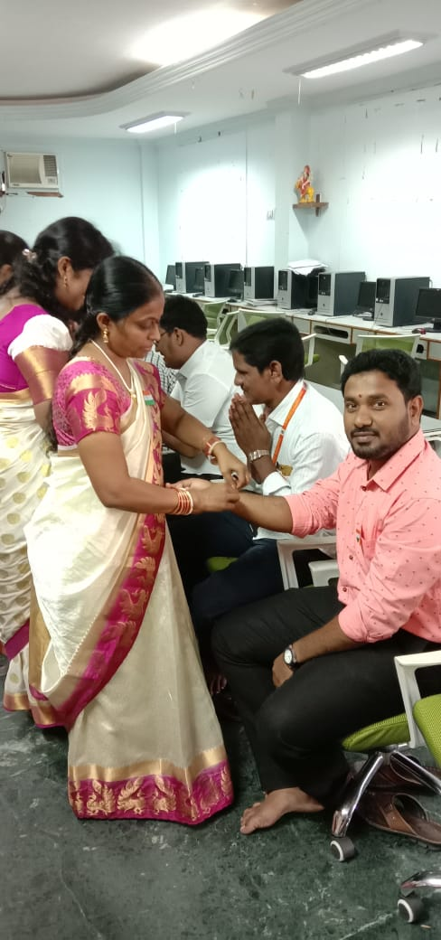

**Christmas:**

Various festivals are celebrated on the campus. Christmas celebrations begin with the preparation of a crib for baby Jesus and Santa Claus distributing gifts. Christmas is a festival to celebrate the birth of Jesus Christ. He was born in Bethlehem on December 25.

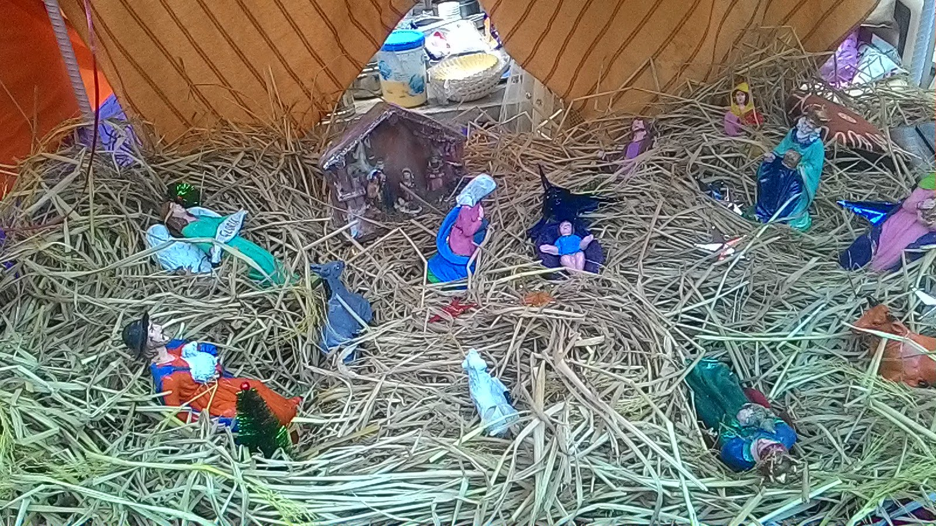

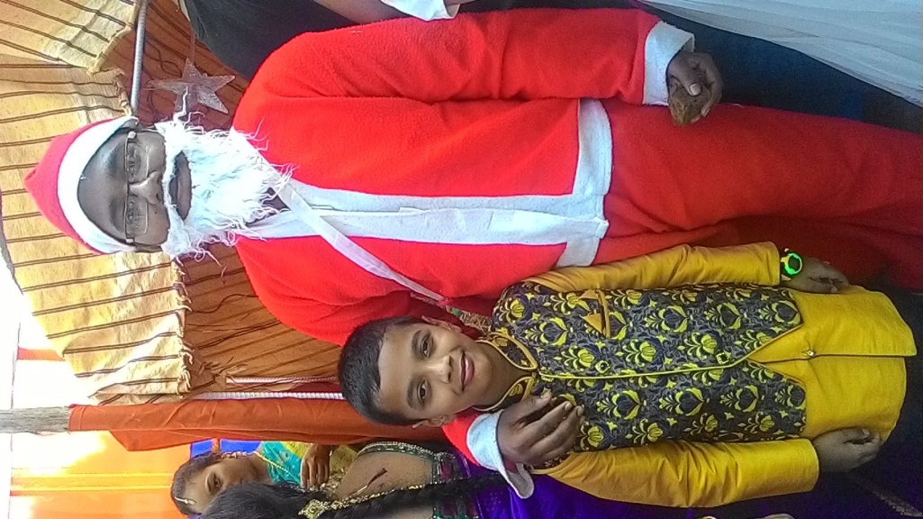

**Ramzan** is season of fasting and donation. Fasting is undertaken for the whole day and meal is taken before sunrise and after sunset. Prayers are offered more fervently during this season.

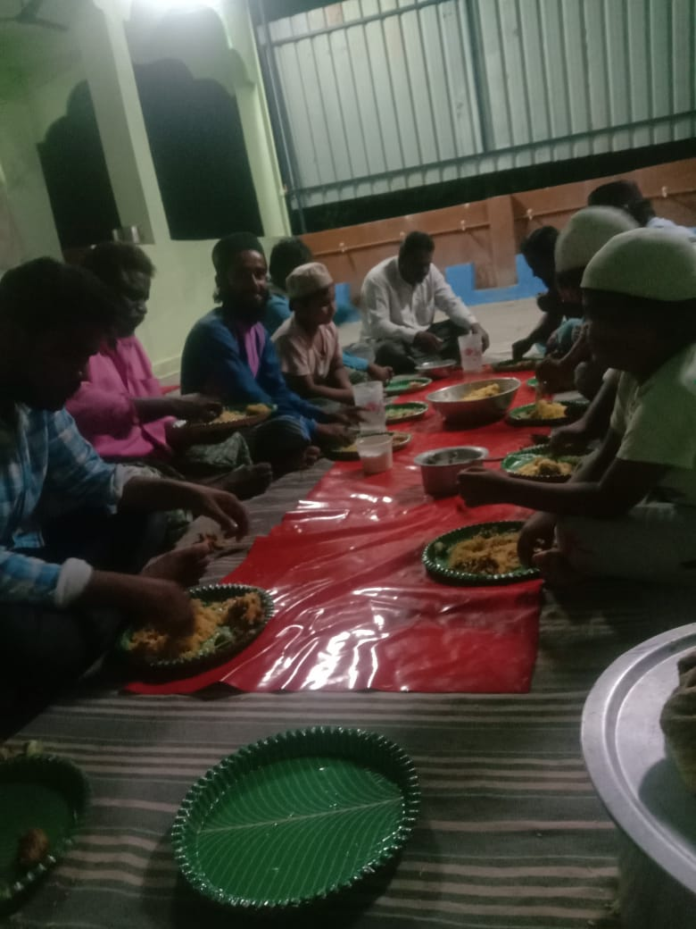

**Holi**

It is a festival of colors. This mainly indicates the beginning of spring. The flame of the forest is widely used to prepare colors and previously only organic colors were used. This helps in rejuvenating the skin because of season change from cold to spring. People use pichkaris to spray the liquid colour on others. It is celebrated with lot of enjoyment and sweets.

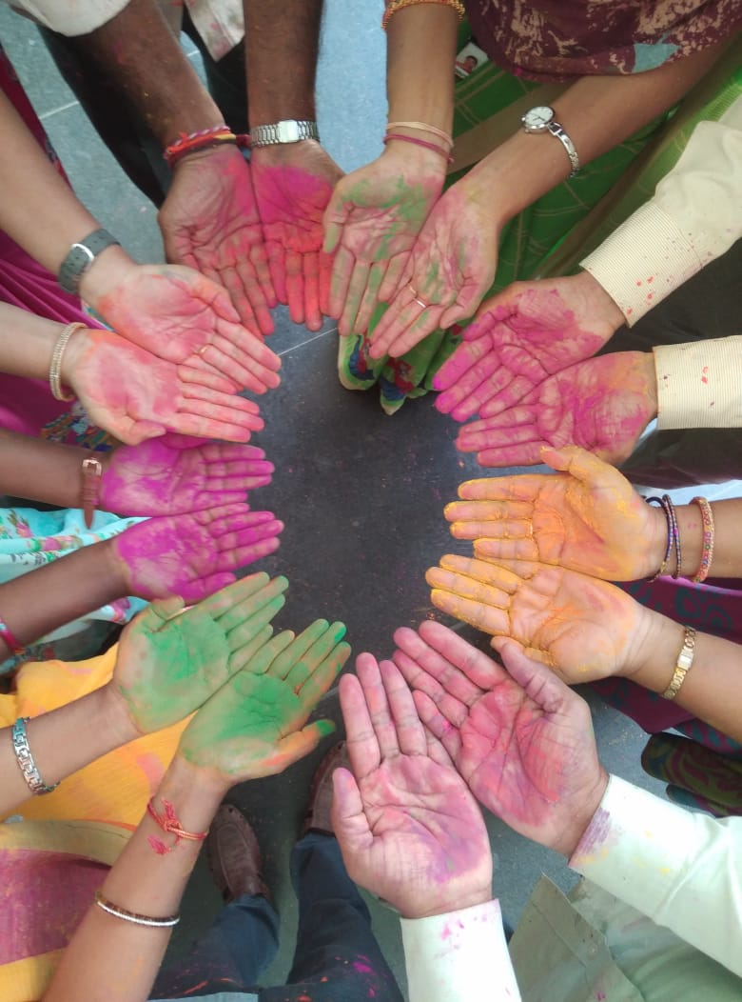

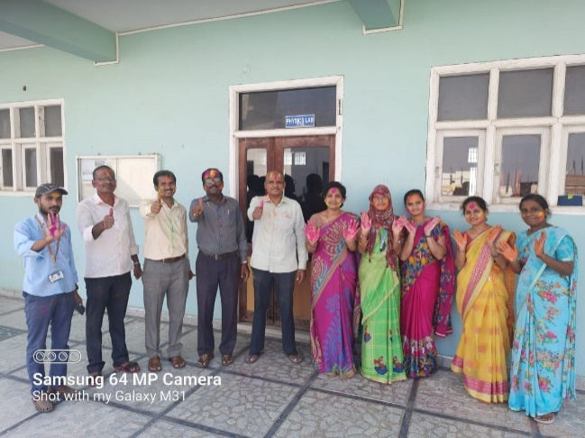

Holi celebration

**Shakambhari:**

Incarnate of Mahadevi. Her name is the one who nourished mankind with fruits and vegetables. It is said that in the end of 100 year lasting famine the supreme paramshakthi incarnated as shatakshishakambhari gave food to the starving. In our college Shakambhari is celebrated with great joy. They decorate with fruits and vegetables. After 1 day these fruits and vegetables are distributed among the staff.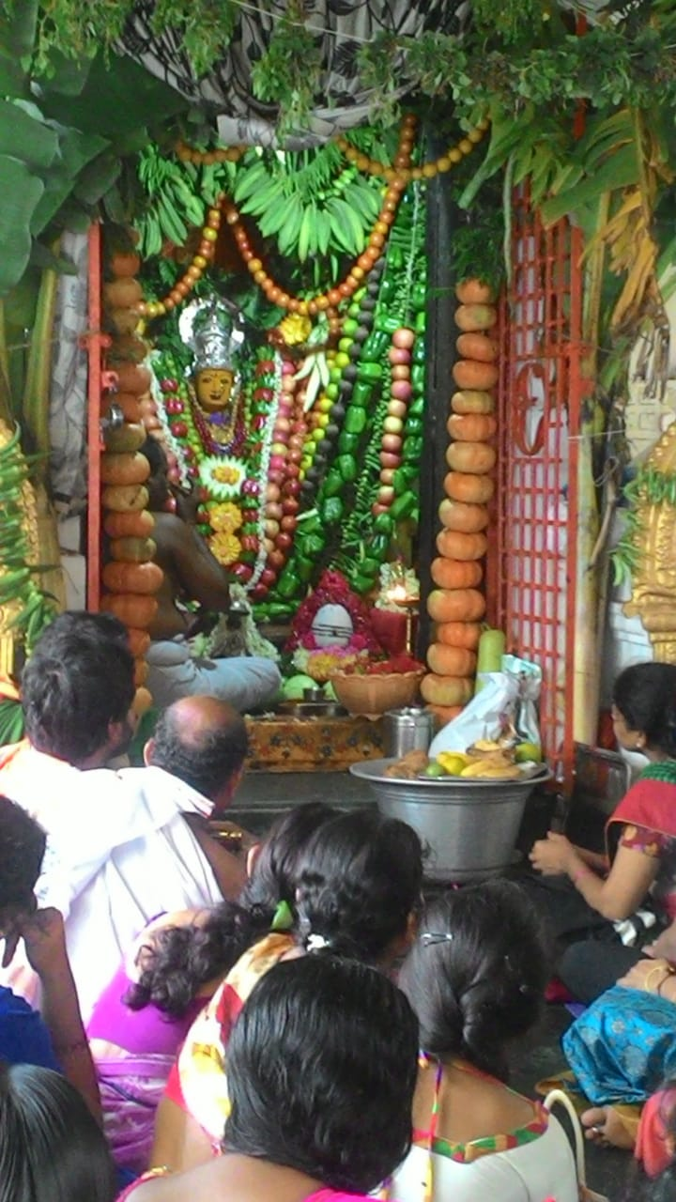

**Celebrations in Campus:**

The students participate in and organize co-curricular and extracurricular activities and different types of student meets and fests. They coordinate with each other to ensure the success of the event. This helps in overcoming all types of Diversity found among students.

**College Day Celebrations**

The day is celebrated during the first half of the academic session. It provides an opportunity to access the achievement of the college. The students actively associated in all the segments of the program. Rather they manage all the activities by themselves. For every college day celebration a reputed Artist or Academician will be invited as Chief guest. The gathering in this occasion will be addressed by the chief guest with special focus on the students.

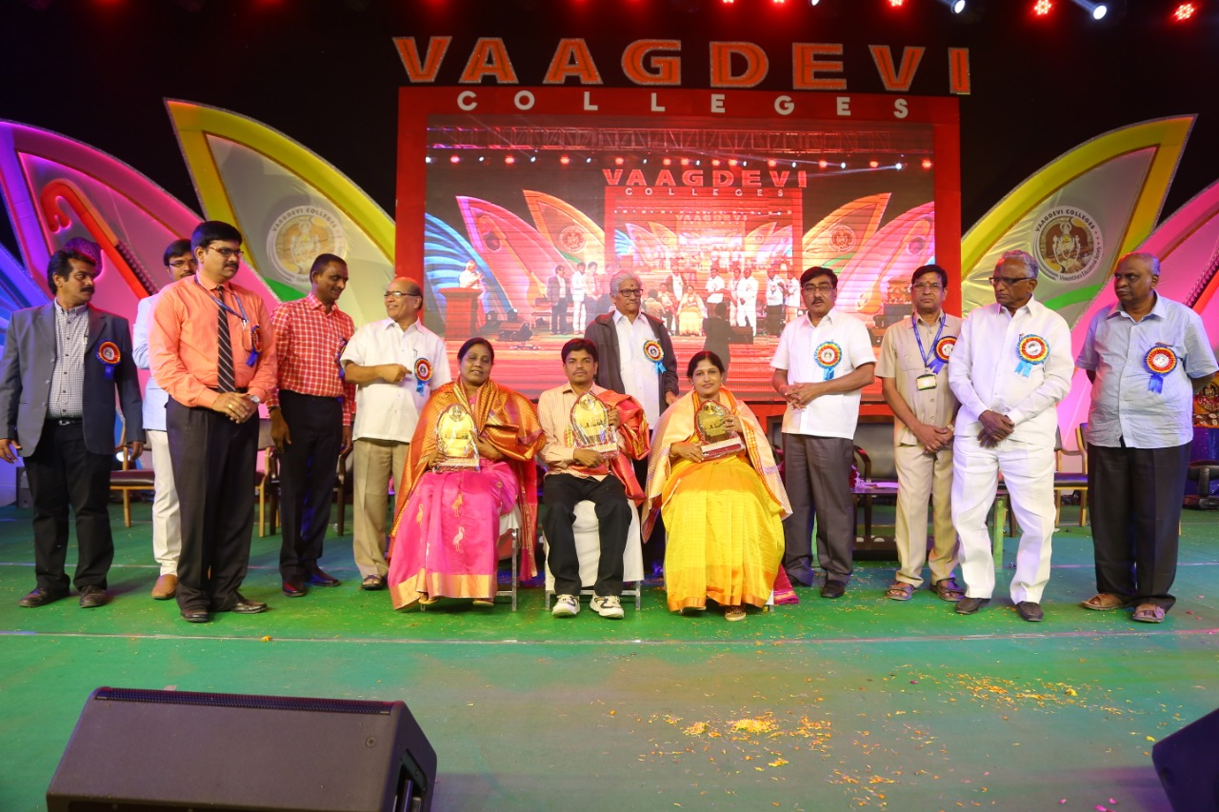

Felicitation on college Day

**Farewell Party.**

Farewell party is celebrated. On this occasion all the Faculty are invited. Principal and course coordinator are the Chief Guests. They tell their experience and their aims, ambitions and expectations. Later on it is followed by cultural programs

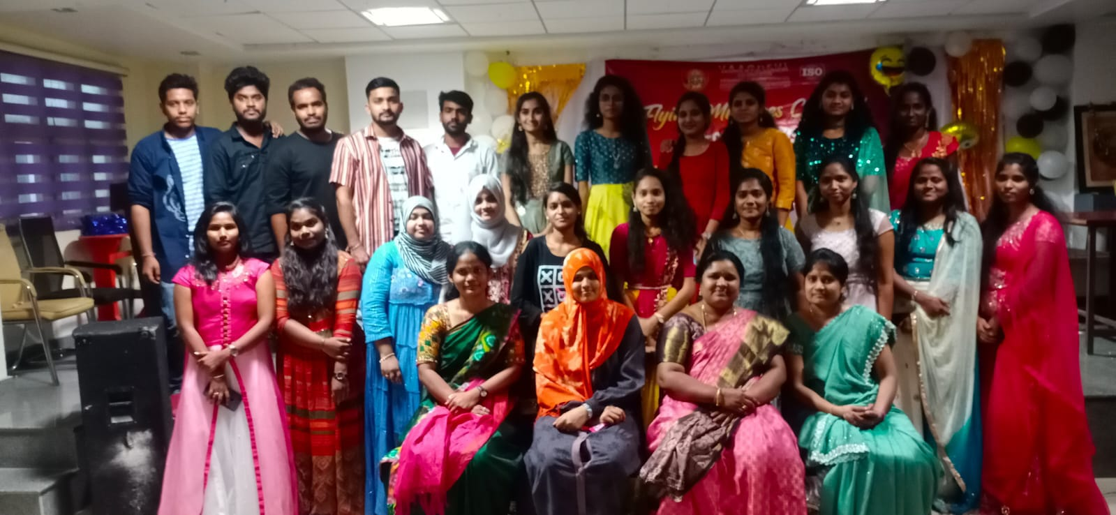

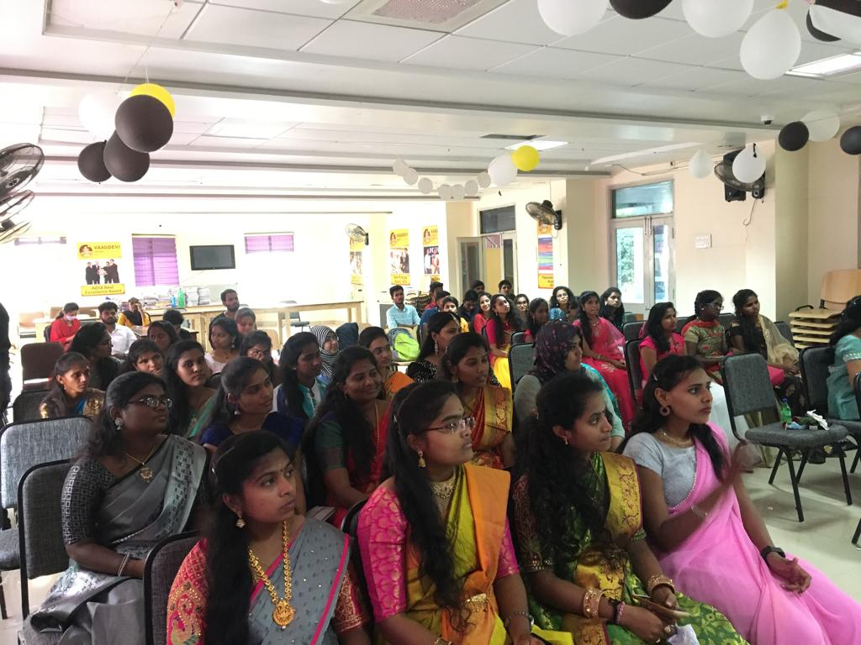

Farewell party of MSc Students

**Jai ho:**

This program was conducted to understand the struggles undertaken by the freedom fighters to attain Independence. To render the national anthem on Independence day and to infuse patriotism in youngsters.

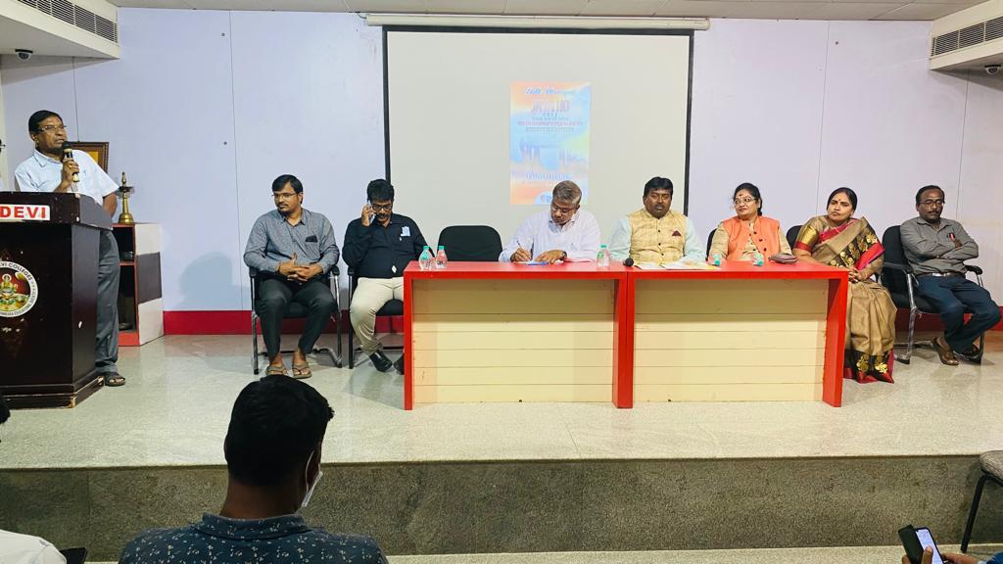

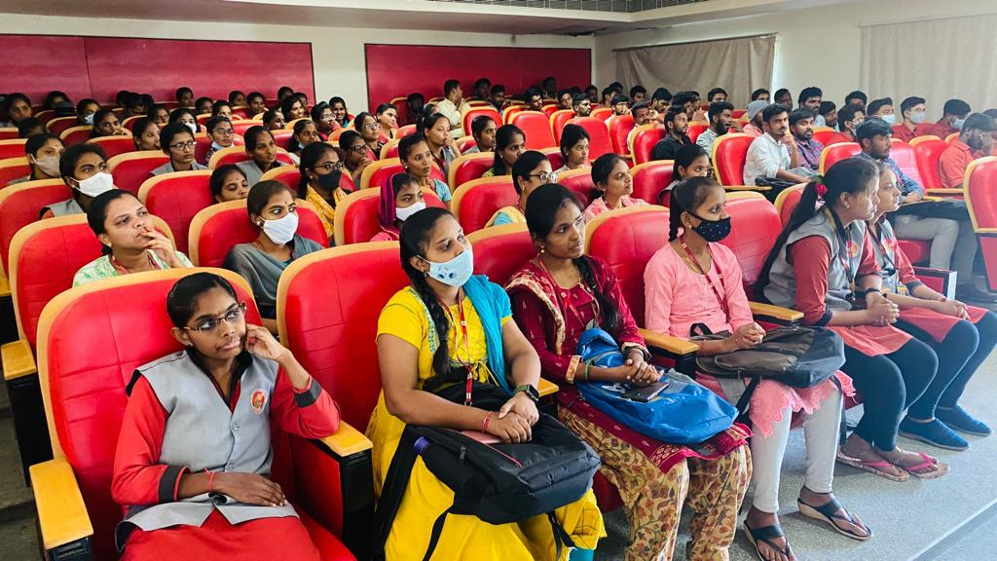

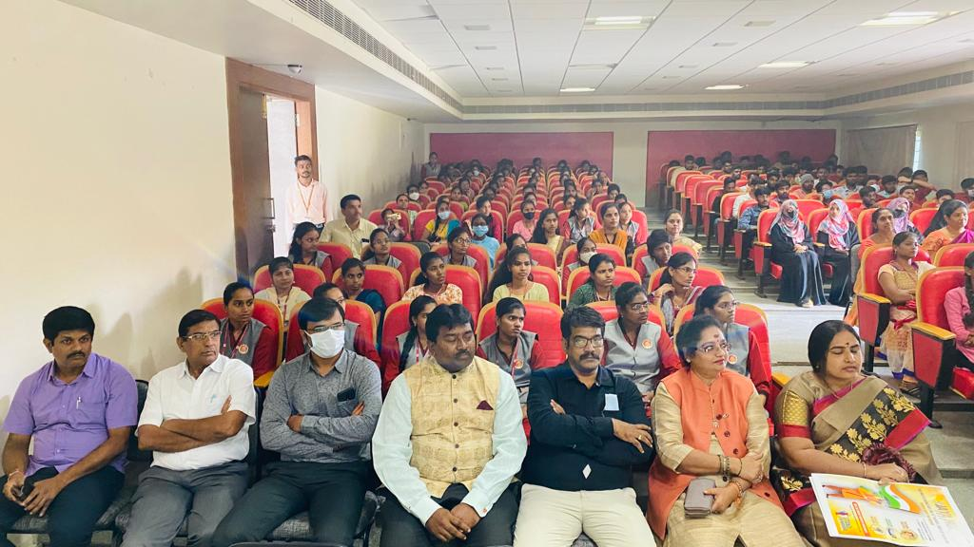

Jai Ho program organized in the college.

**Rakhi for soldiers:**

It is organised by Samskruthi foundation. Rakhi for soldiers was initiated to highlight the risks being taken by the soldiers for protecting us. Raakhi always brings cheer to the soldiers too, who forget all relationships just to protect our frontiers.

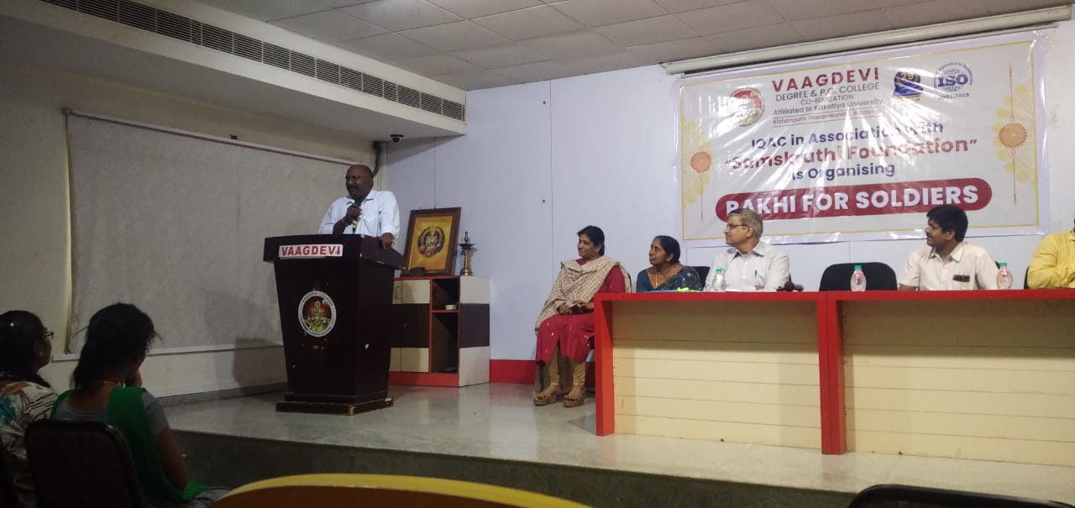

Rakhi for Soldiers